**Branding**

Logo



<https://byui-cse.github.io/wdd130-ww-course/resources/images/logos/z-wwr-crossedoars.png>

**Style Guide**

Color Schema

Color palette URL: <https://coolors.co/160c28-1a936f-88d498-c6dabf-f3e9d2>

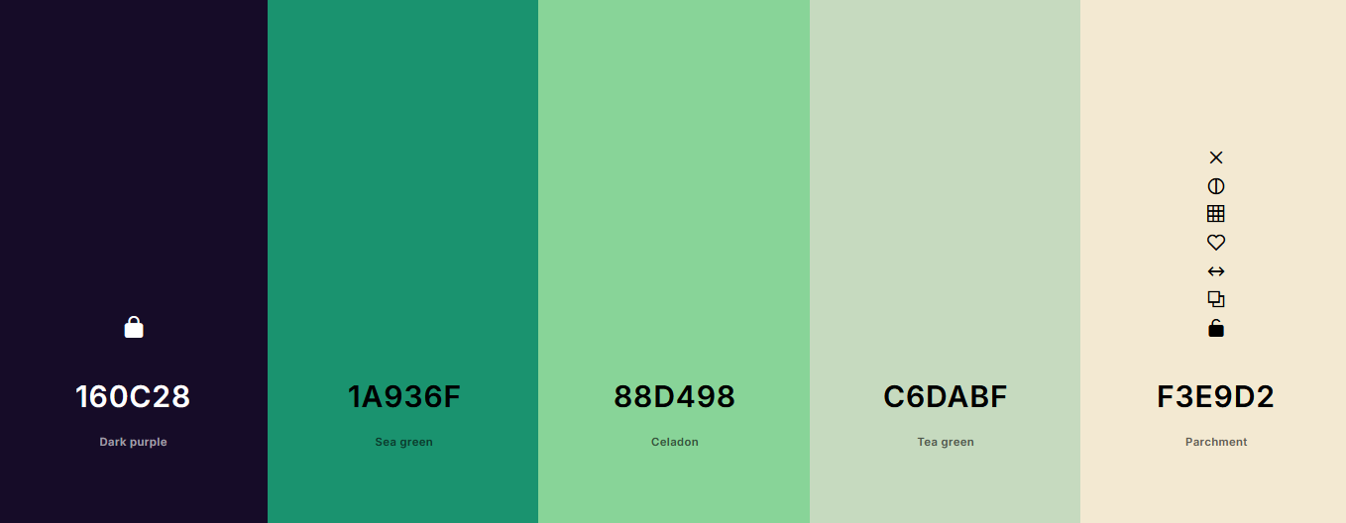

primary-color: #160c28

secondary-color #f3e9d2

accent1-color: #1a936f

accent2-color: #88d498

accent3-color: #c6dabf

**Typography**

Headings: Noto Sans Medium 500

Body: Roboto Light 300, Roboto Regular 400